37.38: The work that must be done is the kinetic energy of the proton.
a) 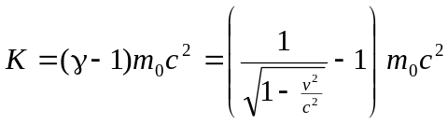
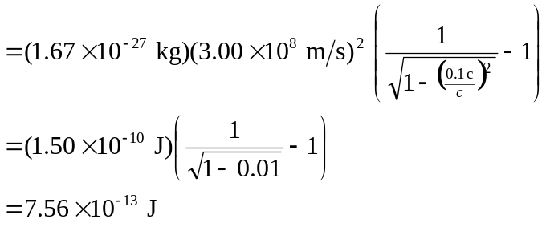
b) 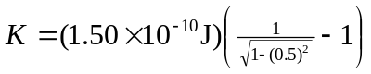
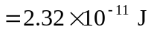
c) 